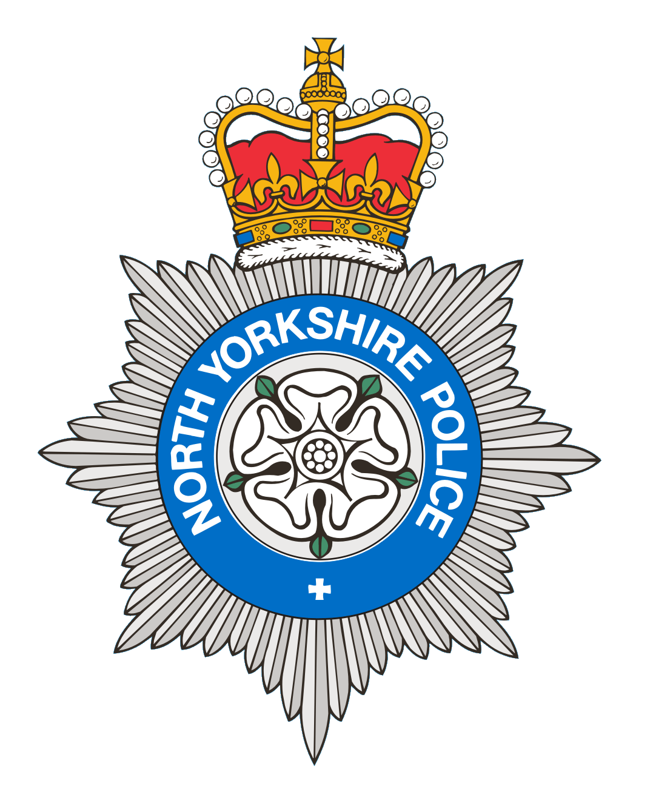
PCSO 3521 Diane Smith
Produced: 17th April 2025
Date of meeting- 22nd April 2025

BROUGH WITH ST GILES
PARISH COUNCIL MEETING 22nd April 2025
POLICE REPORT

19/03/2025 – 17/04/2025

Please note that under the police crime reporting system, all reports of criminal activity are recorded as crimes. However, if at a later date it is ascertained that no crime has been committed, this will not show on parish council report due to time delay.

Overall reports recorded for this period = 11
For the same period last year = 9

Crimes = 3
1 Violence – Which was domestic related.
1 Theft – Report of theft of materials from a building site.
1 Stalking/harassment
Reported crime for the same period last year = 2

Anti-Social Behaviour = 2

ASB Nuisance – 1 report of youths being a nuisance outside a shop. 1 report of a disturbance in a street, no other reports were received.
Reports of ASB for the same period last year = 2

Administration = 0
Highway Disruption = 6
Road Traffic Collision = 0
Road Related Incident = 0
Other reports for the same period last year= 2

Personal/Safety/Warning Incidents = 0
Other reports for the same period last year = 3

Community Messaging
North Yorkshire Community Messaging allows members of the public to register to receive alerts, crime notifications and community news from organisations. It is a way of maintaining contact with Neighbourhood Watch and Rural Watch groups. Neighbourhood & Rural Watch have their own database within community messaging for their members.

​You can sign up to receive alerts as a member of the public here:
https://www.northyorkshirecommunitymessaging.co.uk/

If you wish to speak to your local Neighbourhood PCSO you can send an e-mail to PCSO3521 Diane Smith diane.smith@northyorkshire.police.uk phone 101, choose option 2, and follow the prompts.

